**END OF TERM-2 EXAM**

**S.1 ENTREPRENEURSHIP**

**DURATION: 1Hr & 30 Mins**

1. What do you understand by the term **entrepreneurship**? **(3 marks)**

…………………………………………………………………………………………………

…………………………………………………………………………………………………

1. Imagine you have been approached by the LC of your village inviting you to advice the youths on the qualities of a successful entrepreneur during their village meeting. Mention any **five** ***qualities of a successful entrepreneur*** you would base on to advise the youth. **(5 marks)**

i.…………………………………………………………………………………………………

ii. ………………………………………………………………………………………………

iii. ………………………………………………………………………………………………

iv. ………………………………………………………………………………………………

v. ………………………………………………………………………………………………

1. Your friends are joining senior one, give ***three merits*** to convince them why they should be entrepreneurs  **(6 marks)**

i.…………………………………………………………………………………………………

ii. ………………………………………………………………………………………………

iii. ………………………………………………………………………………………………

1. Mukisa is operating a mobile money business in Soroti city, offering a number of money transfer services. Give any **three** ***benefits enjoyed*** by Mukisa in his business. **(6 marks)**

i.…………………………………………………………………………………………………

ii. ………………………………………………………………………………………………

iii. ………………………………………………………………………………………………

1. **Read the Case study below and answer the questions that follow:**

**LONGIDO FARM**

After studying an agricultural course at the University, Ofwono decided to start Longido Farm/business using the little savings he had made on the pocket money plus the loan he got from DFCU Bank. He started with eight Freshian cows and mushroom growing though it was his first business. He searched on the internet to get knowledge on how to make mushroom spawns/seeds than buying them. Milking of cows was being done by machines.

He supplies milk to schools and hotels around the area as he supplies mushroom to all supermarkets around. Customers can make orders on WhatsApp, email or sending a message on the business phone number. Payments are made through bank, mobile money or even on Cente-Mobile and the messages evidencing payments are sent on the business phone number.

The business has got many customers and employs 6 people. The business products have improved on the health and nutrition of the people. Ofwono listens to his employees whenever they try to give him some solutions to business problems. There is provision of biogas from cow dung and farm manure which have led to improved standard of living and agricultural harvest.

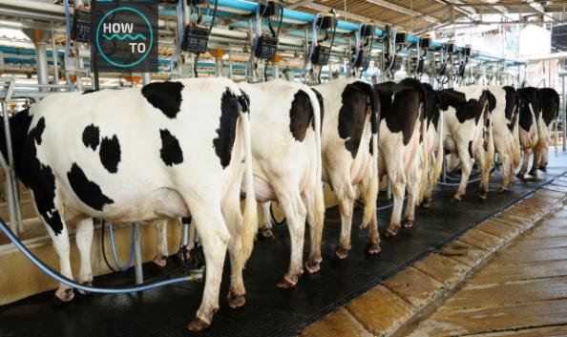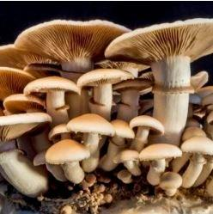

(a) Identify **four** ***problems*** which Ofwono solved in his community. **(04 marks)**

…………………………………………………………………………………………………

…………………………………………………………………………………………………

…………………………………………………………………………………………………

…………………………………………………………………………………………………

…………………………………………………………………………………………………

…………………………………………………………………………………………………

(b)State any **four** ***qualities*** which have enabled Ofwono to become a ***successful*** in business. **(04 marks)**

…………………………………………………………………………………………………

…………………………………………………………………………………………………

…………………………………………………………………………………………………

…………………………………………………………………………………………………

…………………………………………………………………………………………………

…………………………………………………………………………………………………

(c) How did Ofwono ***employ*** **creativity** and **innovation** in his business? **(02 marks)**

…………………………………………………………………………………………………

…………………………………………………………………………………………………

…………………………………………………………………………………………………

…………………………………………………………………………………………………

…………………………………………………………………………………………………

…………………………………………………………………………………………………

(d) With evidence, state **four** ways how the community ***benefited*** from Longido Farm. **(04 marks)**

…………………………………………………………………………………………………

…………………………………………………………………………………………………

…………………………………………………………………………………………………

…………………………………………………………………………………………………

…………………………………………………………………………………………………

…………………………………………………………………………………………………

(e) Identify any **3** ***risks*** which the above business is exposed to. **(03 marks)**

(i) …………………………………………………………………………………………………...

(ii) …………………………………………………………………………………………………...

(iii) …………………………………………………………………………………………………...

(f) Advise the business owner (Ofwono) on any **three** measures to be ***undertaken to minimize*** the risks mentioned in (e) above. **(03 marks)**

(i) …………………………………………………………………………………………………...

(ii) …………………………………………………………………………………………………...

(iii) …………………………………………………………………………………………………...

**END**